**Fifa21 Project**

**EDA:**

What we did with this project is to do a specific EDA and manage to answer several outcomes.

The data initially was a raw database and in the first instance we noticed that we had some data cleaning to do. After some cleaning we also decided to drop some columns that were useless for our outcomes.

Once we reached the final version of the cleaning we started to work on the outcomes.

**Outcomes:**

Our first outcome was the count of the loan date of all the players to determine when its the best time to start looking for new players.

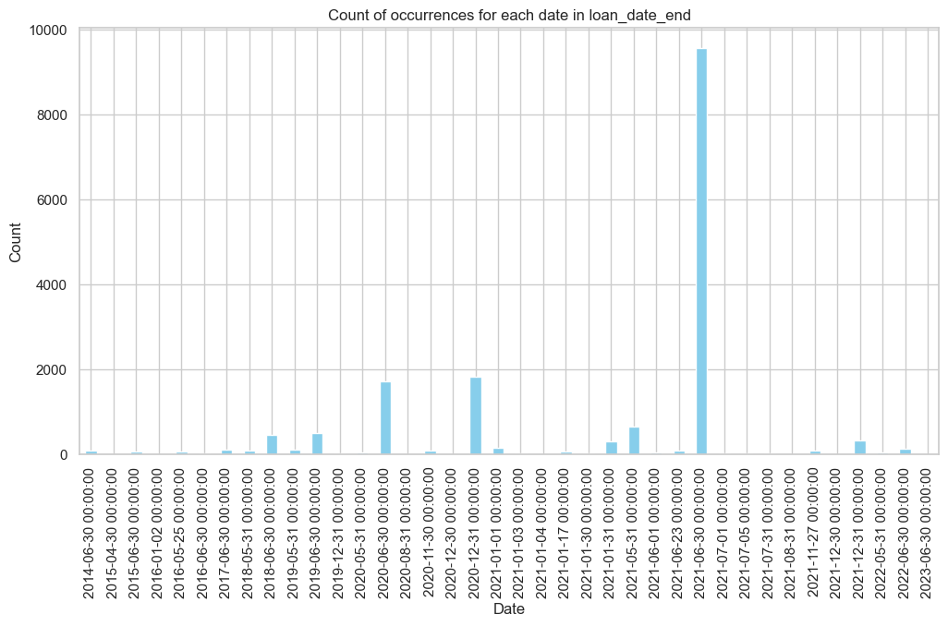

As you can see, the best date to start negotiating with the players was at the end of the season, on June 30th.

Next, we started working on the market value of the players.

name value_in_millions

9331 K. Mbappé 105.5

2650 Neymar Jr 90.0

2871 K. De Bruyne 87.0

2287 R. Lewandowski 80.0

5030 S. Mané 78.0

5109 M. Salah 78.0

4166 V. van Dijk 75.5

3665 J. Oblak 75.0

4049 R. Sterling 72.5

3961 H. Kane 71.0

With a simple code we showed the best 10 players of the market in descending order based on the value, before that we cleaned the data and edited the value_in_millions to adapt it to a numerical value. Before that we had categorial values because of the “M” “K” and “€” so we dropped it in order to show the outcome correctly.

Just before that we created the mean, standard and the min/max of some values to determine the info describing some important values:

| index | count | mean | std | min | 25% | 50% | 75% | max |

+---------------------+---------+------+-----+------+-------+------+---

| Age | 17125.0 | 25.3 | 4.9 | 16.0 | 21.0 | 25.0 | 29.0 | 53.0 |

| Overall Rating | 17125.0 | 67.0 | 6.9 | 38.0 | 62.0 | 67.0 | 72.0 | 93.0 |

| Best Overall | 17125.0 | 67.9 | 6.6 | 42.0 | 64.0 | 68.0 | 72.0 | 93.0 |

| Potential | 17125.0 | 72.5 | 5.8 | 47.0 | 69.0 | 72.0 | 76.0 | 95.0 |

| Value (in millions) | 17125.0 | 2.6 | 5.4 | 0.0 | 0.375 | 0.8 | 2.4 | 105.5 |

We created a new outcome about the nationwide of all the players, with more info, like the top 20 nationalities, the top 10 countries with highest OVA (overall) and the top 10 clubs with highest OVA in the game.

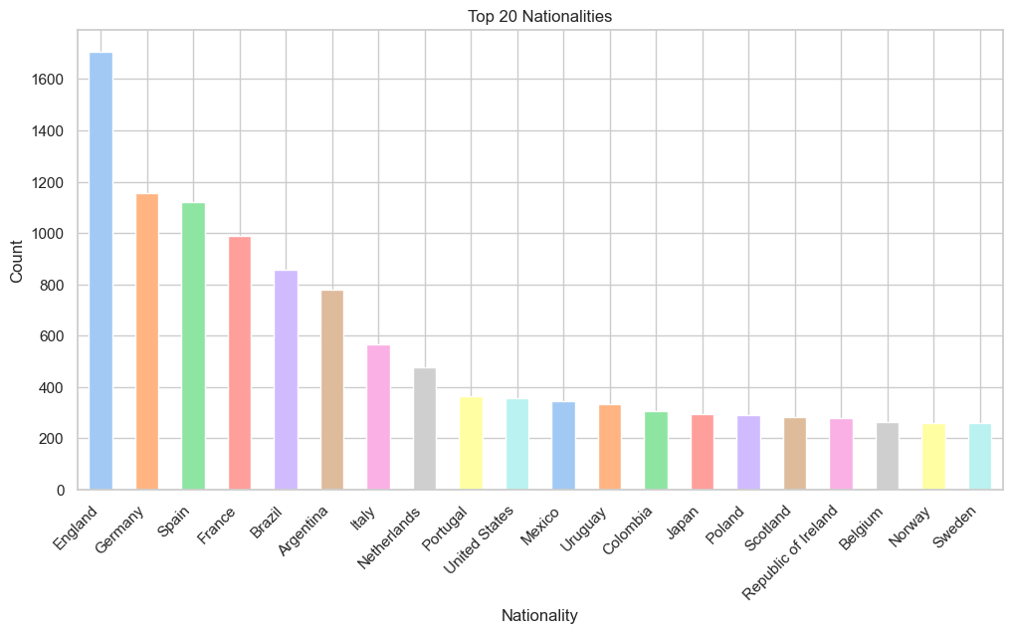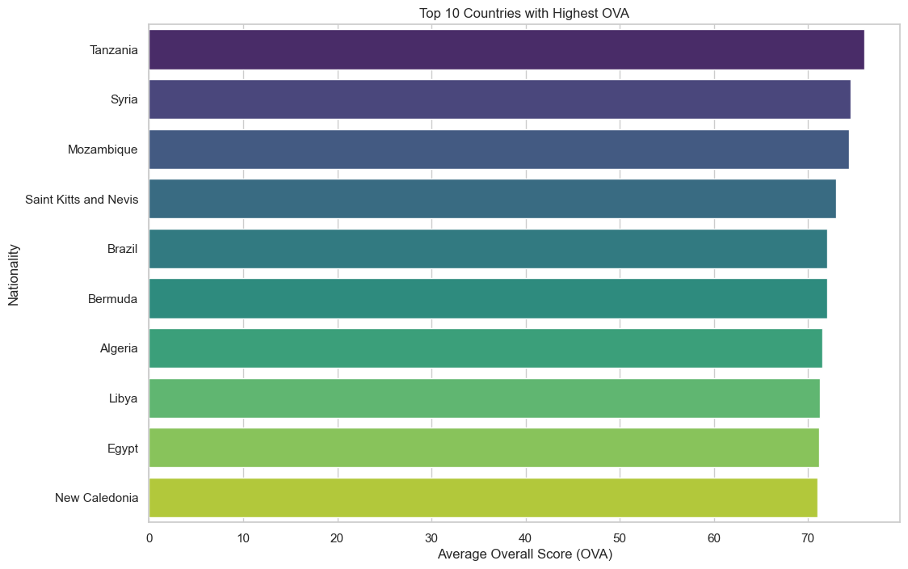

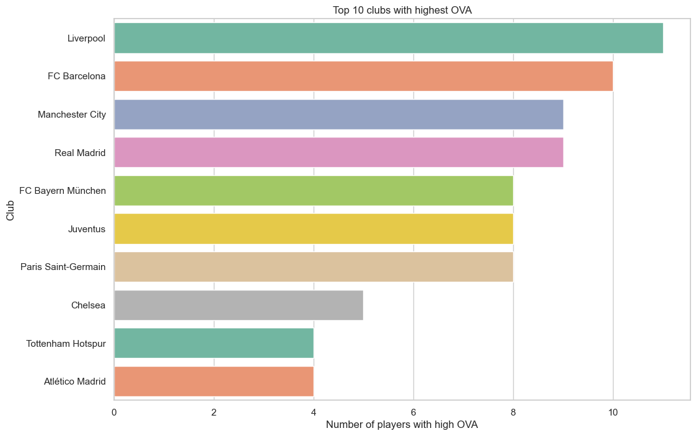

In this first instance of the date we focused first on the teams, right before that we focused on the players to have an insight of some of the outcomes.

Our first outcome was to reach the best 10 players based on the OVA.

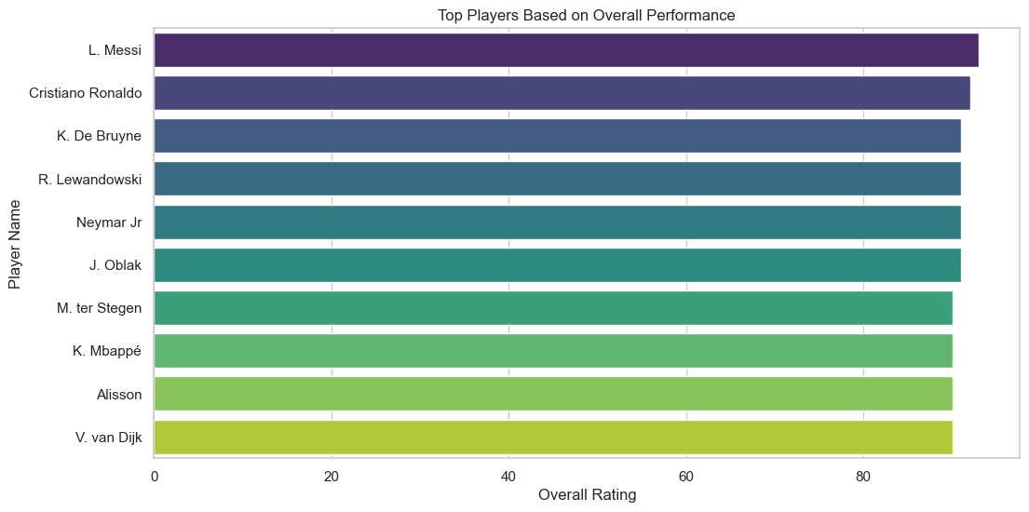

After the first outcome we decided to start working on some of the top 10 roles in the game, divided on:

* Best defenders
* Best scorers
* Best dribblers
* Best goalkeepers
* Best vision
* Best athletes

Showing all of them in different plots:

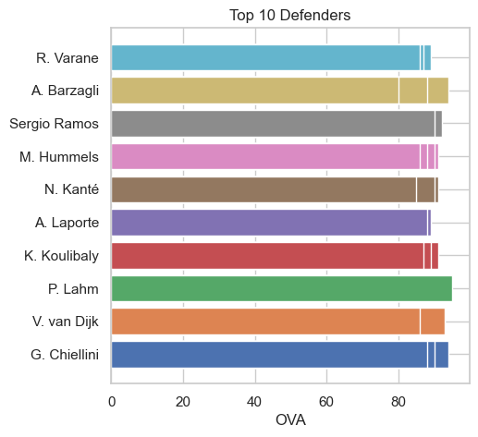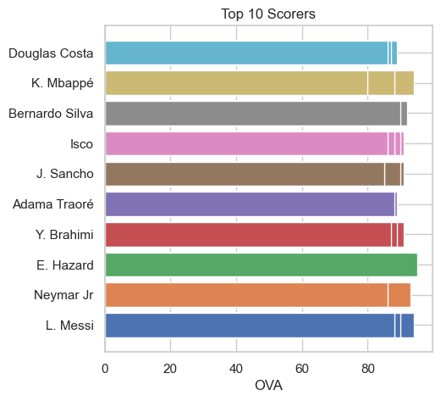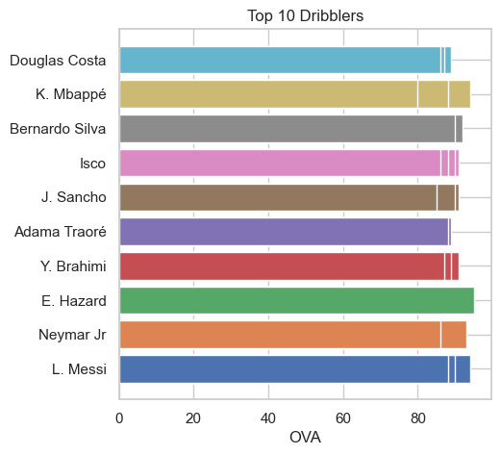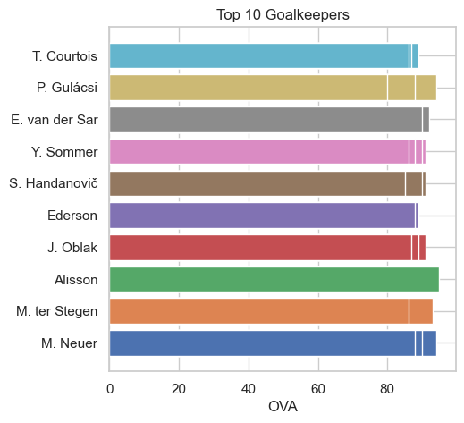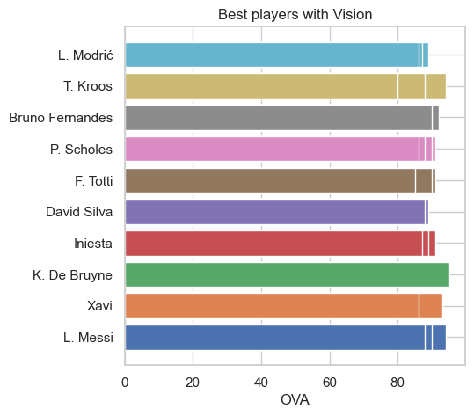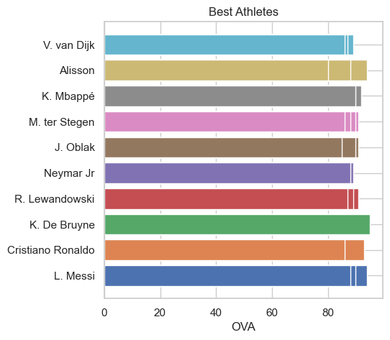

We included some outcomes that we thought it was interesting to add. Like some outcomes including the goalkeepers and comparing it with the other players.

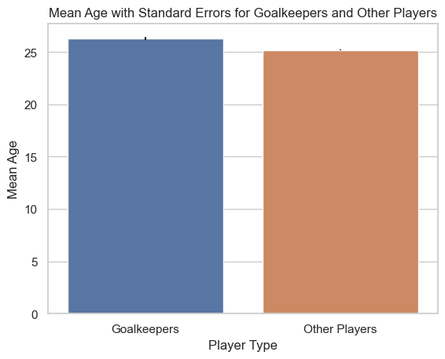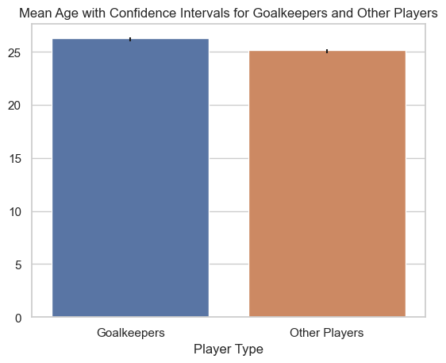

Mean Age for Goalkeepers: 26.28

Confidence Interval for Goalkeepers: (26.00, 26.57)

Mean Age for Other Players: 25.17

Confidence Interval for Other Players: (25.10, 25.25)

And some others really interesting like the best 11 players for a perfect team in the game:

|  | **ova** | **name** | **position** | **attacking** | **defending** | **vision** | **power** | **finishing** | **mentality** |
| --- | --- | --- | --- | --- | --- | --- | --- | --- | --- |
| 2287 | 91 | R. Lewandowski | ST | 423 | 96 | 79.0 | 420 | 94 | 391 |
| 662 | 89 | S. Agüero | ST | 411 | 83 | 83.0 | 403 | 94 | 341 |
| 5030 | 90 | S. Mané | LW | 410 | 122 | 85.0 | 406 | 90 | 358 |
| 5109 | 90 | M. Salah | RW | 392 | 122 | 84.0 | 393 | 91 | 376 |
| 1753 | 88 | T. Kroos | CM | 397 | 205 | 90.0 | 355 | 76 | 378 |
| 3630 | 89 | Casemiro | CDM | 349 | 259 | 80.0 | 437 | 64 | 396 |
| 6387 | 87 | A. Robertson | LB | 328 | 248 | 79.0 | 365 | 57 | 378 |
| 9212 | 87 | Alexander-Arnold | RB | 365 | 241 | 84.0 | 370 | 56 | 371 |
| 4166 | 90 | V. van Dijk | CB | 316 | 272 | 65.0 | 402 | 52 | 347 |
| 681 | 89 | Sergio Ramos | CB | 374 | 263 | 71.0 | 402 | 65 | 414 |
| 3665 | 91 | J. Oblak | GK | 95 | 57 | 65.0 | 268 | 11 | 140 |

**Machine Learning:**

Most of the outcomes were done showing some interesting data and info regarding the best players. But because of all the amount of players we had we did the machine learning on Linear Regression, choosing the OVA and the Age for the process.

All the values shown on the heat map were cleaned and standarized first.

First we created the heat map for the data:

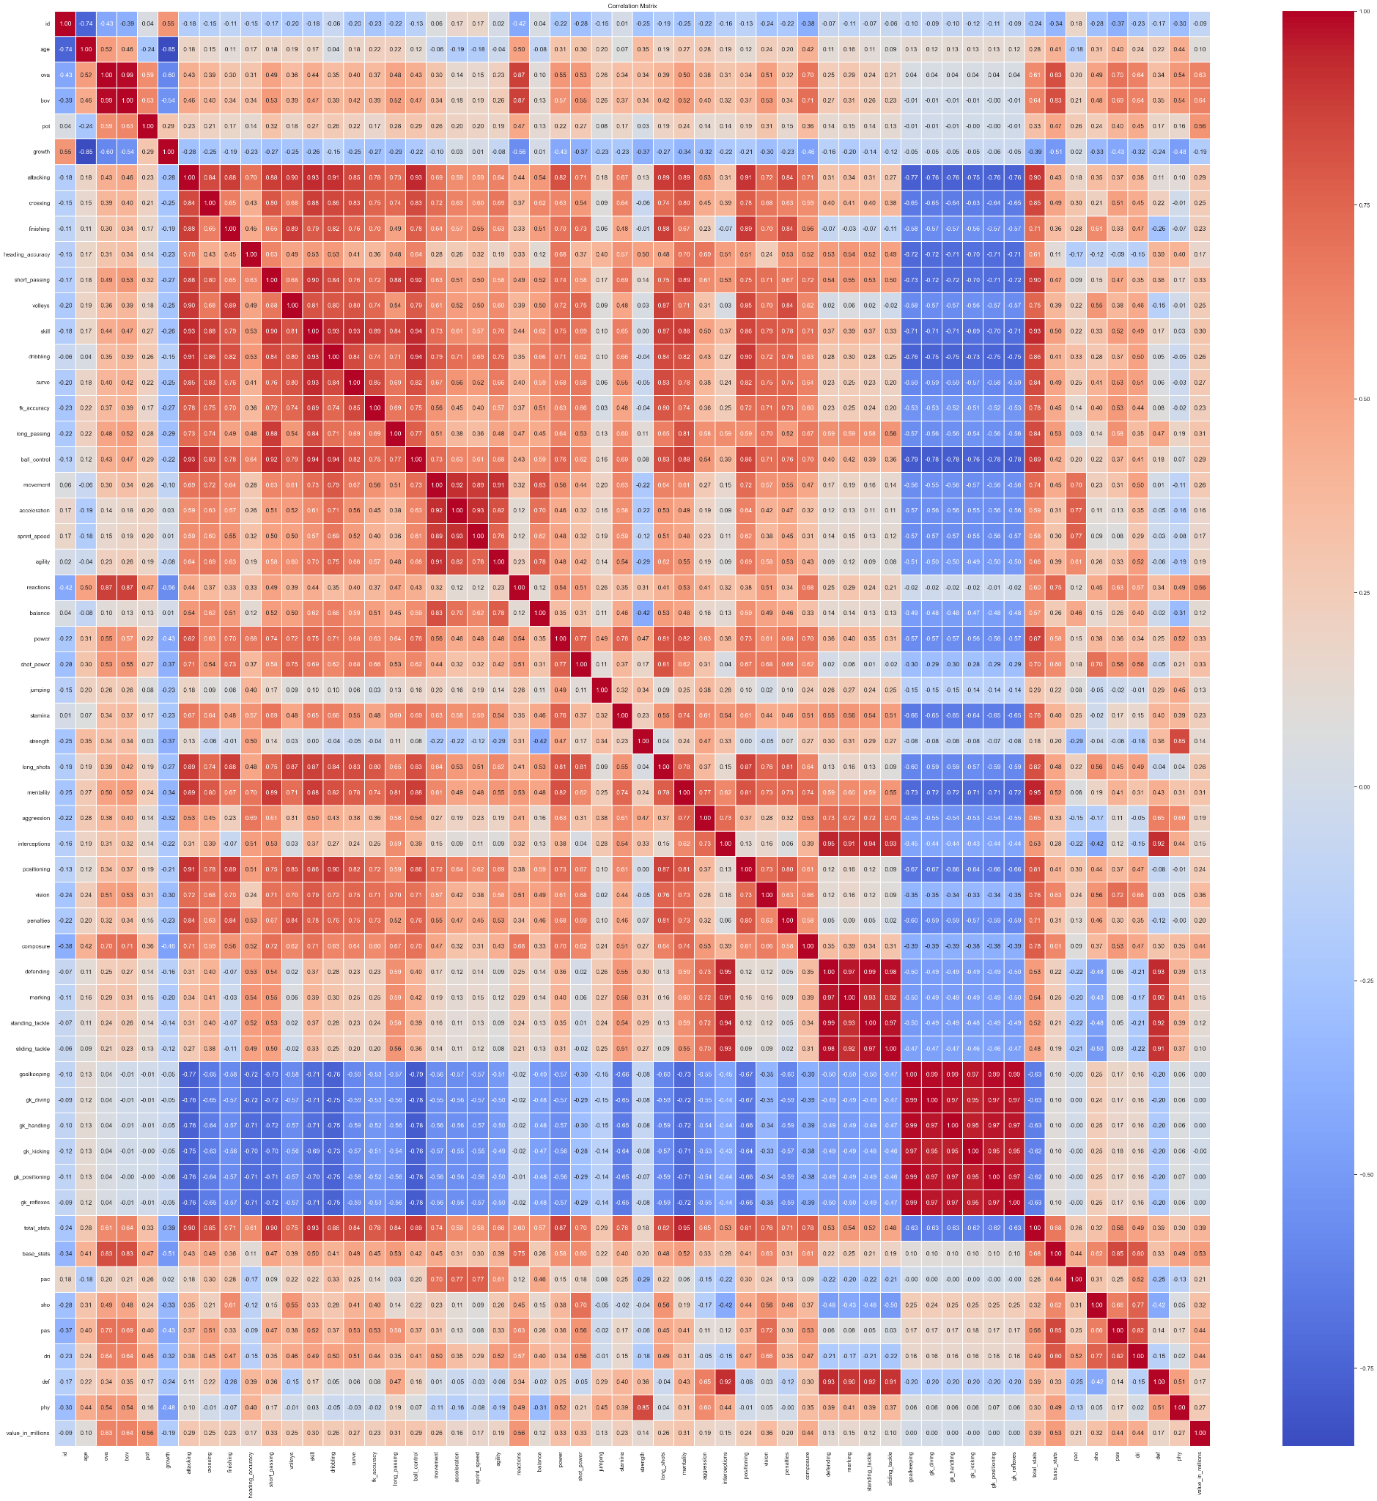

Mean Squared Error: 35.14

R-squared: 0.26

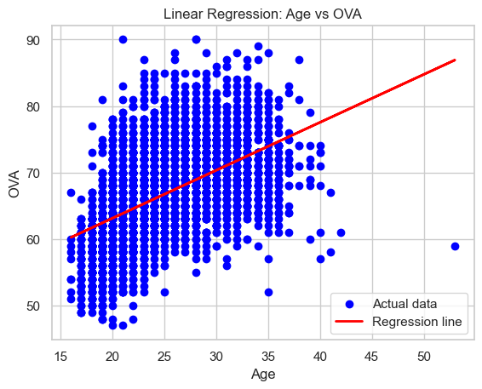

OLS Regression Results

==============================================================================

Dep. Variable: ova R-squared: 0.267

Model: OLS Adj. R-squared: 0.267

Method: Least Squares F-statistic: 6250.

Date: Sat, 06 Jan 2024 Prob (F-statistic): 0.00

Time: 11:56:28 Log-Likelihood: -54623.

No. Observations: 17125 AIC: 1.093e+05

Df Residuals: 17123 BIC: 1.093e+05

Df Model: 1

Covariance Type: nonrobust

==============================================================================

coef std err t P>|t| [0.025 0.975]

------------------------------------------------------------------------------

const 48.8155 0.234 208.674 0.000 48.357 49.274

age 0.7181 0.009 79.055 0.000 0.700 0.736

==============================================================================

Omnibus: 278.506 Durbin-Watson: 1.636

Prob(Omnibus): 0.000 Jarque-Bera (JB): 348.398

Skew: 0.238 Prob(JB): 2.22e-76

Kurtosis: 3.511 Cond. No. 134.

=========================================================================

After this analysis we decided to create another machine learning on Spearman method just to compare the data:

Mean Squared Error: 1.05

R-squared: 0.98

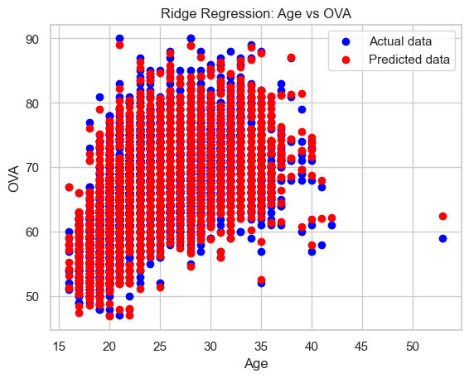

Mean Squared Error: 1.05

R-squared: 0.98

Coefficients: [0.08314047 0.96810844]

Intercept: -0.86

OLS Regression Results

==============================================================================

Dep. Variable: ova R-squared: 1.000

Model: OLS Adj. R-squared: 1.000

Method: Least Squares F-statistic: 1.201e+25

Date: Sat, 06 Jan 2024 Prob (F-statistic): 0.00

Time: 11:56:29 Log-Likelihood: 3.8706e+05

No. Observations: 17125 AIC: -7.740e+05

Df Residuals: 17075 BIC: -7.736e+05

Df Model: 49

Covariance Type: nonrobust

===============================================================================

coef std err t P>|t| [0.025 0.975]

-------------------------------------------------------------------------------------

const -1.51e-14 8.58e-12 -0.002 0.999 -1.68e-11 1.68e-11

id -1.653e-16 1.26e-17 -13.170 0.000 -1.9e-16 -1.41e-16

age 8.882e-16 1.49e-13 0.006 0.995 -2.91e-13 2.93e-13

bov -7.327e-15 3.12e-13 -0.023 0.981 -6.19e-13 6.04e-13

pot 1.0000 3.06e-13 3.27e+12 0.000 1.000 1.000

growth -1.0000 3.09e-13 -3.24e+12 0.000 -1.000 -1.000

attacking -1.283e-13 5.49e-14 -2.337 0.019 -2.36e-13 -2.07e-14